**  
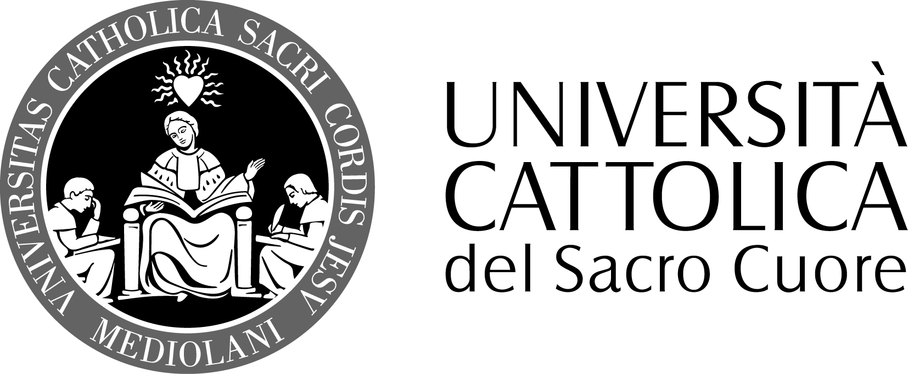ERIC-VOEGELIN-GESELLSCHAFT e.V.**

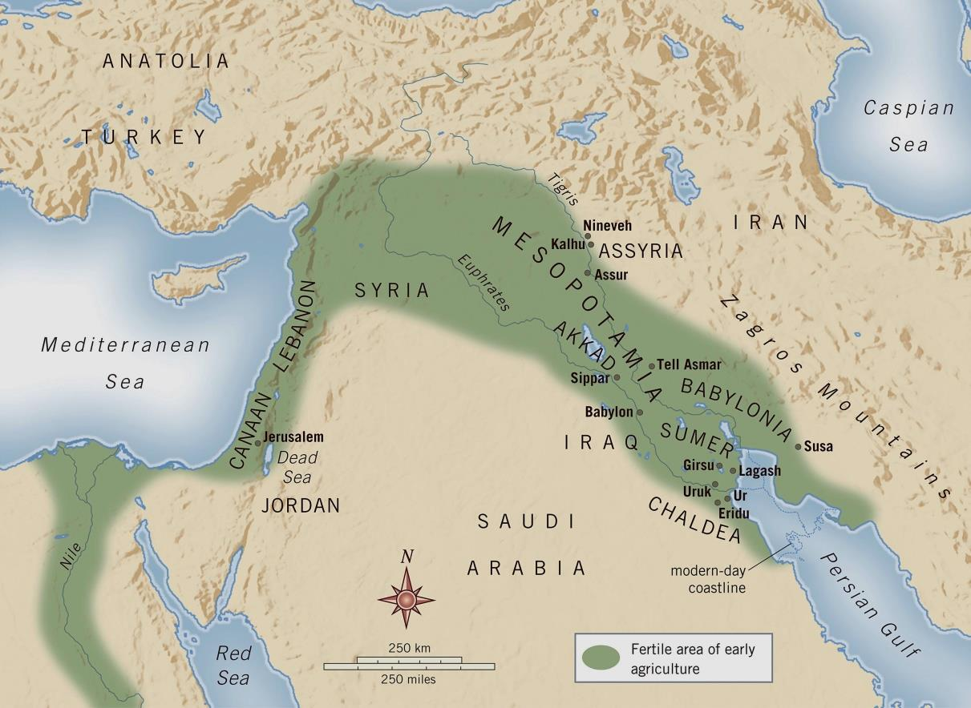AN INTERNATIONAL SCHOLARLY CONFERENCE

**ISRAEL AND THE COSMOLOGICAL EMPIRES   
OF THE ANCIENT ORIENT**

**Symbols of Order in Eric Voegelin’s Order and History, Vol. 1**

**IIN ERIC VOEGELINS ORDER AND HISTORY I**

**Internationale wissenschaftliche Tagung**

**15. – 16. Mai 2017**

**Munich**

**Hochschule für Philosophie  
Kaulbachstr. 31 a**

**IN ERIC VOEGELINS ORDER AND HISTORY I**



**9:30 a.m.–1:00 p.m.**

**PANEL 3. ON THE OLD TESTAMENT**

**Dominik Markl SJ** (Istituto biblico – Roma)  
*Divine Law and the Emergence of Monotheism*

**Eckart Otto** (Ludwig-Maximilians-Universität – München)

*Assyria and Israel. The Political Theory of the Book of* Deuteronomy *and its Reception by Max Weber and Eric Voegelin*

**Ignacio Carbajosa** (Universidad San Dámaso-Madrid)

*‘The Exodus of Israel from itself’: the Role of the Prophets in Voegelin’s*Israel and Revelation

**3:00 p.m.–7:00 p.m.**

**PANEL 4. ISRAEL AND REVELATION  
  
Marvin A. Sweeney** (Claremont School of Theology)  
*Judaism and Revelation*

**David Walsh** (The Catholic University of America – Washington DC)

*Voegelin’s Handling of the Event of Revelation in* Israel and Revelation

**Catherine Chalier** (Université Paris Ouest)  
*“It concerns what is for me a foreign world and I can only learn.” (Eric Voegelin): What about Judaism in*Order and History*, Vol. 1*  
  
*Discussion*

**9:00 a.m.–1:00 p.m.**

**PANEL 1.** **FORMS OF CIVILISATION**

**Nicoletta Scotti Muth** (Università Cattolica del Sacro Cuore –Milano)

*Die Anwendung des klassischen Form-Begriffes in* Order and History*, Bd. 1*

**Peter Machinist** (Harvard University)

*Eric Voegelin and his Orientalist Critics: The Case of William Foxwell Albright*

**Dietrich Wildung** (FU Berlin; former Director of the Egyptian Museum of Berlin) *Zeitlos* – *Zum Geschichtsbild der alten Ägypter*

**Giorgio Buccellati** (University of California – Los Angeles)

*The Cosmos before Cosmology. Forebodings of Order in Prehistory*

**3:00 p.m.–7:00 p.m.**

**PANEL 2. ORDER AND HISTORY**

**Massimo Marassi** (Università Cattolica del Sacro Cuore – Milano)

*Die symbolische und transzendentale Struktur der Geschichte:* Order and History*, Bd. 1*

**Friedhelm Hartenstein** (Ludwig-Maximilians-Universität – München)

*Israels ‚Entdeckung‘ der Geschichte als hermeneutischer Schlüssel für Eric Voegelins* Order and History*, Bd. 1*

**John Milbank** (University of Nottingham)

*Order, Representation and Liturgy: Voegelin’s Platonic and Biblical Metahistory*

*Discussion*

**Monday – May 15, 2017**

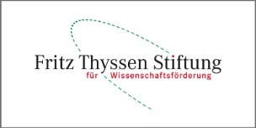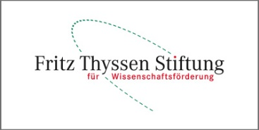

Financial support provided by the Fritz Thyssen Foundation.

C O N T A C T:  
  
*Conference Director:* Nicoletta Scotti Muth – Email: nicoletta.scotti@unicatt.it  
  
*Assistant:* Matthias Schmid – Email: periagoge@gmx.de

*For further information see:* http://eric-voegelin-gesellschaft.de/tagungen/israel.html

**Conference languages are German and English. No registration or conference fees.**

Gefördert aus den Mitteln der Fritz-Thyssen-Stiftung, Köln.

Leitende Tagungsorganisation: Prof. aggr. Nicoletta Scotti Muth  
 . KONTAKTDATEN

Mitarbeit: Matthias Schmid M.A.  
 KONTAKTDATEN